HUMAN RESOURCE ANALYTICS DASHBOARD FOR ALTERA EMPLOYEE DATA

PREPARED BY:

IWUJI GLORY EBUBECHUKWU

GROUP 3

DATE:

16th JULY, 2024

**Table of Contents**

• Introduction

• Data Preparation

• Dashboard Design and Features

• Key Insights

• Recommendations

• Conclusion

**INTRODUCTION**

This is the Altera HR Analytics Project. In this comprehensive report, we delve into the critical aspects of Altera's human resources data to extract actionable insights and trends that can drive strategic decision-making within our organization.

In today's dynamic business environment, leveraging data analytics is no longer a luxury but a necessity. It empowers organizations to optimize workforce management, enhance employee performance, and foster a more inclusive and productive work environment. This project aims to harness the power of data to provide a clear picture of our current HR landscape and identify opportunities for improvement.

This analysis covers several key areas:

* **Workforce Composition**: Examining the gender distribution, age demographics, and employment types across the organization.
* **Recruitment Channels**: Identifying the most effective channels for attracting top talent.
* **Training Programs**: Assessing the distribution and impact of training programs across different departments.
* **Departmental Performance**: Analyzing KPI achievements and awards distribution to identify high-performing areas and those needing improvement.
* **Employee Demographics**: Understanding the education levels and length of service of our employees to better tailor our HR strategies.

Throughout this report, we will present detailed findings from our HR analytics dashboards, highlight key insights, and provide strategic recommendations. These insights will not only help in addressing the current challenges but also in capitalizing on opportunities to attract, retain, and develop top talent within Altera.

**DASHBOARD DESIGN AND FEATURES**

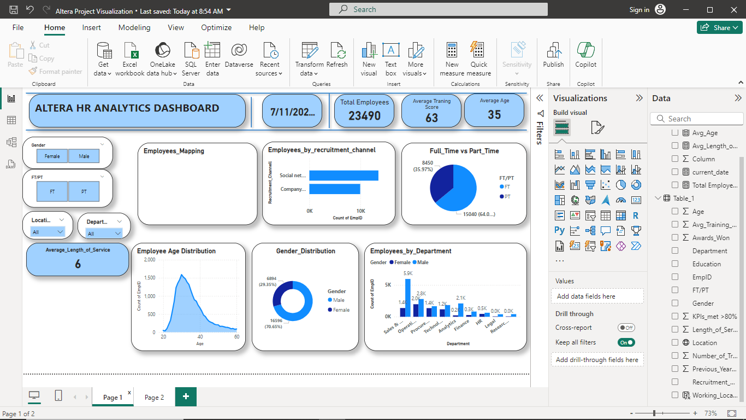

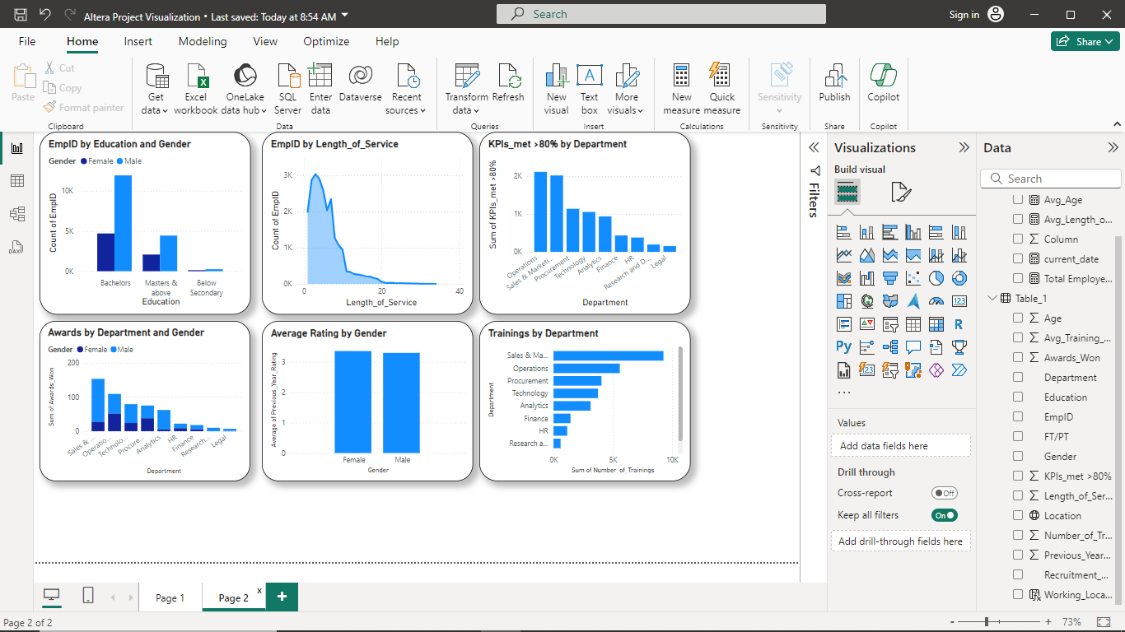

**Features:**

1. **Total Employees**: Altera has a total workforce of 23,490 employees.
2. **Gender Distribution**: The workforce is predominantly male, with 16,596 males (70.65%) and 6,894 females (29.35%).
3. **Full-Time vs. Part-Time**: A significant majority of the employees work full-time (15,040 employees, 64.03%), compared to part-time employees (8,450 employees, 35.97%).
4. **Age Distribution**: The average age of employees is 35, with the majority of employees aged between 25 to 40 years.
5. **Recruitment Channels**:
   * Social networks and company websites are the primary recruitment channels.
6. **Departments**:
   * The Operations department has the highest number of employees (5.9k), followed by Sales & Marketing (5k) and Technical (2.8k).
7. **Average Training Score**: The average training score across the company is 63.
8. **Length of Service**: The average length of service for employees is 6 years.
9. **Education Level and Gender**:

* The majority of employees hold a Bachelor’s degree, with males significantly outnumbering females in this category.
* Employees with Master's and above education levels are more balanced between genders, though still male-dominated.

1. **Length of Service:**
   * Most employees have a length of service between 0 and 10 years, with a peak around 3-5 years.
2. **KPIs Met by Department**:
   * Operations, Sales & Marketing, and Procurement departments have the highest number of employees meeting KPIs above 80%.
   * Research and Legal departments have the lowest performance in terms of meeting KPIs.
3. **Awards by Department and Gender**:
   * The Sales & Marketing department has the highest number of awards won, followed by Operations.
   * Males dominate in terms of awards won across all departments.
4. **Average Rating by Gender**:
   * Both male and female employees have similar average ratings, indicating equitable performance across genders.
5. **Trainings by Department**:
   * The Sales & Marketing department has the highest number of trainings conducted, followed by Operations and Procurement.
   * Departments like HR and Research have significantly fewer trainings.

**Key Insight: Altera HR Analytics Overview**

**1. Total Employees and Gender Distribution:** Altera has a substantial workforce of 23,490 employees. The gender distribution reveals a predominantly male workforce, with 16,596 males (70.65%) and 6,894 females (29.35%). This significant gender gap highlights a potential area for diversity and inclusion initiatives.

**2. Full-Time vs. Part-Time Employment:** A majority of Altera's employees work full-time (15,040 employees, 64.03%), while a notable proportion work part-time (8,450 employees, 35.97%). This distribution could indicate flexibility in work arrangements, catering to employees with varying needs and preferences.

**3. Age Distribution:** The average age of employees at Altera is 35, with the majority aged between 25 to 40 years. This suggests a relatively young workforce, which can be advantageous in terms of energy and adaptability but might require continuous training and development to retain and nurture talent.

**4. Recruitment Channels:** Social networks and company websites are the primary recruitment channels. This modern approach to recruitment likely enhances Altera's ability to attract tech-savvy and socially connected talent.

**5. Departmental Distribution:** The Operations department employs the highest number of employees (5.9k), followed by Sales & Marketing (5k) and Technical (2.8k). This distribution suggests that Altera places significant emphasis on operational efficiency and market presence.

**6. Average Training Score:** The average training score across the company is 63. This indicates that while training is a focus, there might be room for improvement in training effectiveness or participation.

**7. Length of Service:** The average length of service for employees at Altera is 6 years, with most employees having served between 0 and 10 years, peaking around 3-5 years. This suggests a moderate level of employee retention, but also points to potential turnover challenges as employees reach mid-career stages.

**8. Education Level and Gender:** Most employees hold a Bachelor’s degree, with males significantly outnumbering females in this category. For employees with Master’s and above education levels, the gender distribution is more balanced, though still male-dominated. This highlights potential areas for targeted educational support and career development programs for females.

**9. KPI Performance by Department:** The Operations, Sales & Marketing, and Procurement departments have the highest number of employees meeting KPIs above 80%. Conversely, the Research and Legal departments have the lowest KPI performance. This may indicate the need for enhanced support and resources in the underperforming departments.

**10. Awards by Department and Gender:** The Sales & Marketing department leads in awards won, followed by Operations. Males dominate in terms of awards won across all departments, suggesting a potential gender bias in recognition or performance evaluation processes.

**11. Average Rating by Gender:** Both male and female employees have similar average ratings, indicating equitable performance across genders. This is a positive sign of gender equality in performance evaluation.

**12. Trainings by Department:** The Sales & Marketing department conducts the highest number of trainings, followed by Operations and Procurement. Departments like HR and Research have significantly fewer trainings, which might indicate a need for increased training investment in these areas to boost performance and development.

**RECOMMENDATIONS**

cc

**CONCLUSION**

The HR analysis of Altera reveals a robust and predominantly young workforce with a significant male majority. The company's emphasis on full-time employment and strategic recruitment through social networks and company websites supports a dynamic and tech-savvy environment. While operational efficiency and market presence are strong, as indicated by departmental distributions and KPI performance, there are notable opportunities for improvement in gender diversity, training effectiveness, and support for underperforming departments. Overall, Altera's equitable performance ratings across genders and the potential for targeted development programs highlight a promising path toward enhanced employee satisfaction and organizational growth.